Front Cover Book Analysis
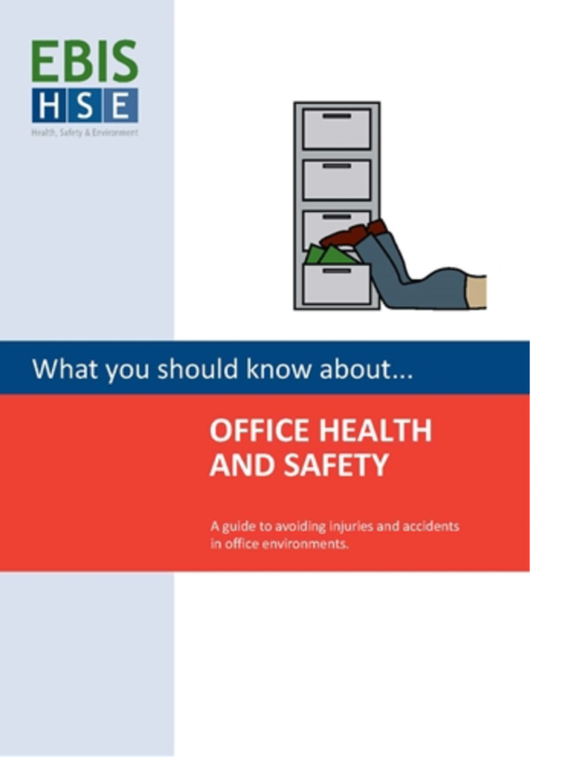
Book One
This Health and Safety booklet is for the workplace and office, due to the font and colour choices it is easy for the viewer to interpret this.

Across the middle of the cover is a red and blue box, I believe this was good choice of layout as it gives it a clean and professional finish, which would be a major factor when designing, as it suits the serious and important topic that it is about. The colour red is typically associated with danger or warning, not only this but it also stands out on the page and grabs attention.
The choice of white font against these block colours is an example of good composition, it is easy and clear to read, and because this is the title of the book, this would be the most important parts on the hierarchy.

The name of the author/ publisher of the book is placed on the top left of the cover, because of the colour of the logo, (green), I believe it draws too much attention away from the title. Because the rest of the book is primarily made up of the primary colours, adding a brighter, more interesting colour into the book is almost too distracting, and this is probably what I need to think about when designing my own cover.

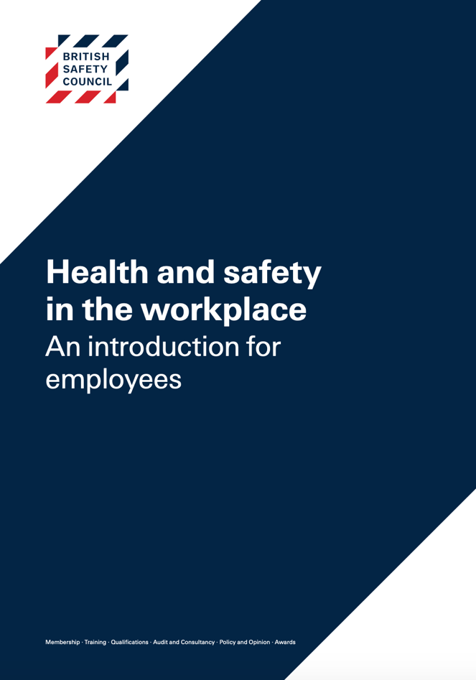
Additionally, this cover also has an image on it, just a basic outline which clearly associates with what the book is about. This is something important I can think about adding to my own booklet, however, it could restrict how much I can play around with the layout.

Book Two
The harsh, contrasting lines on this cover makes it feel more serious and important, the blue and white still complement each other, however, and makes it feel clean and clear. But, on the other hand one could argue that the colours do not represent anything to do with health and safety.

The font they have used is very easy to read, which is important, the title is slightly bolder than the sub-title, which helps it stand out on the page without it looking to busy. Although, the writing on the bottom is so small it’s unclear and hard to read, indicating bad composition.

