Composition and Hierarchy
Composition-
The presentation and arrangement of visual elements.
Hierarchy-
The order in which these visual elements are of importance to a piece of work.
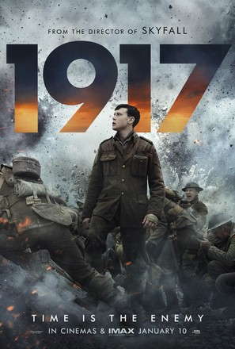
Examples of good composition-
In this poster, for the film 1917, the main character is photographed in the center of the image, meaning your eyes are directly drawn to him, this is important as the film is about him- which you can easily infer from the photo. Additionally, the title of the film is in a bold, colorful font, because of this it stands out and is hard to miss! The whole piece has a very dark, and grey colour scheme, so the fire of orange in the title further adds to the great composition as the numbers pop against the dull of the sky. The title of the work you are advertising would arguably be the most important thing in the hierarchy, which is why the designer has created such a successful poster. The elements that are less important- the directors previous work, is in a smaller font, as the designer would realize that these would be lower down in the hierarchy. However, the font still shows consistency, and matches to the others, creating a less busy piece, further demonstrating good composition. It gets its main points across in order of importance, as well as drawing people in with the dramatic photography, everything is there for a reason and has a purpose.

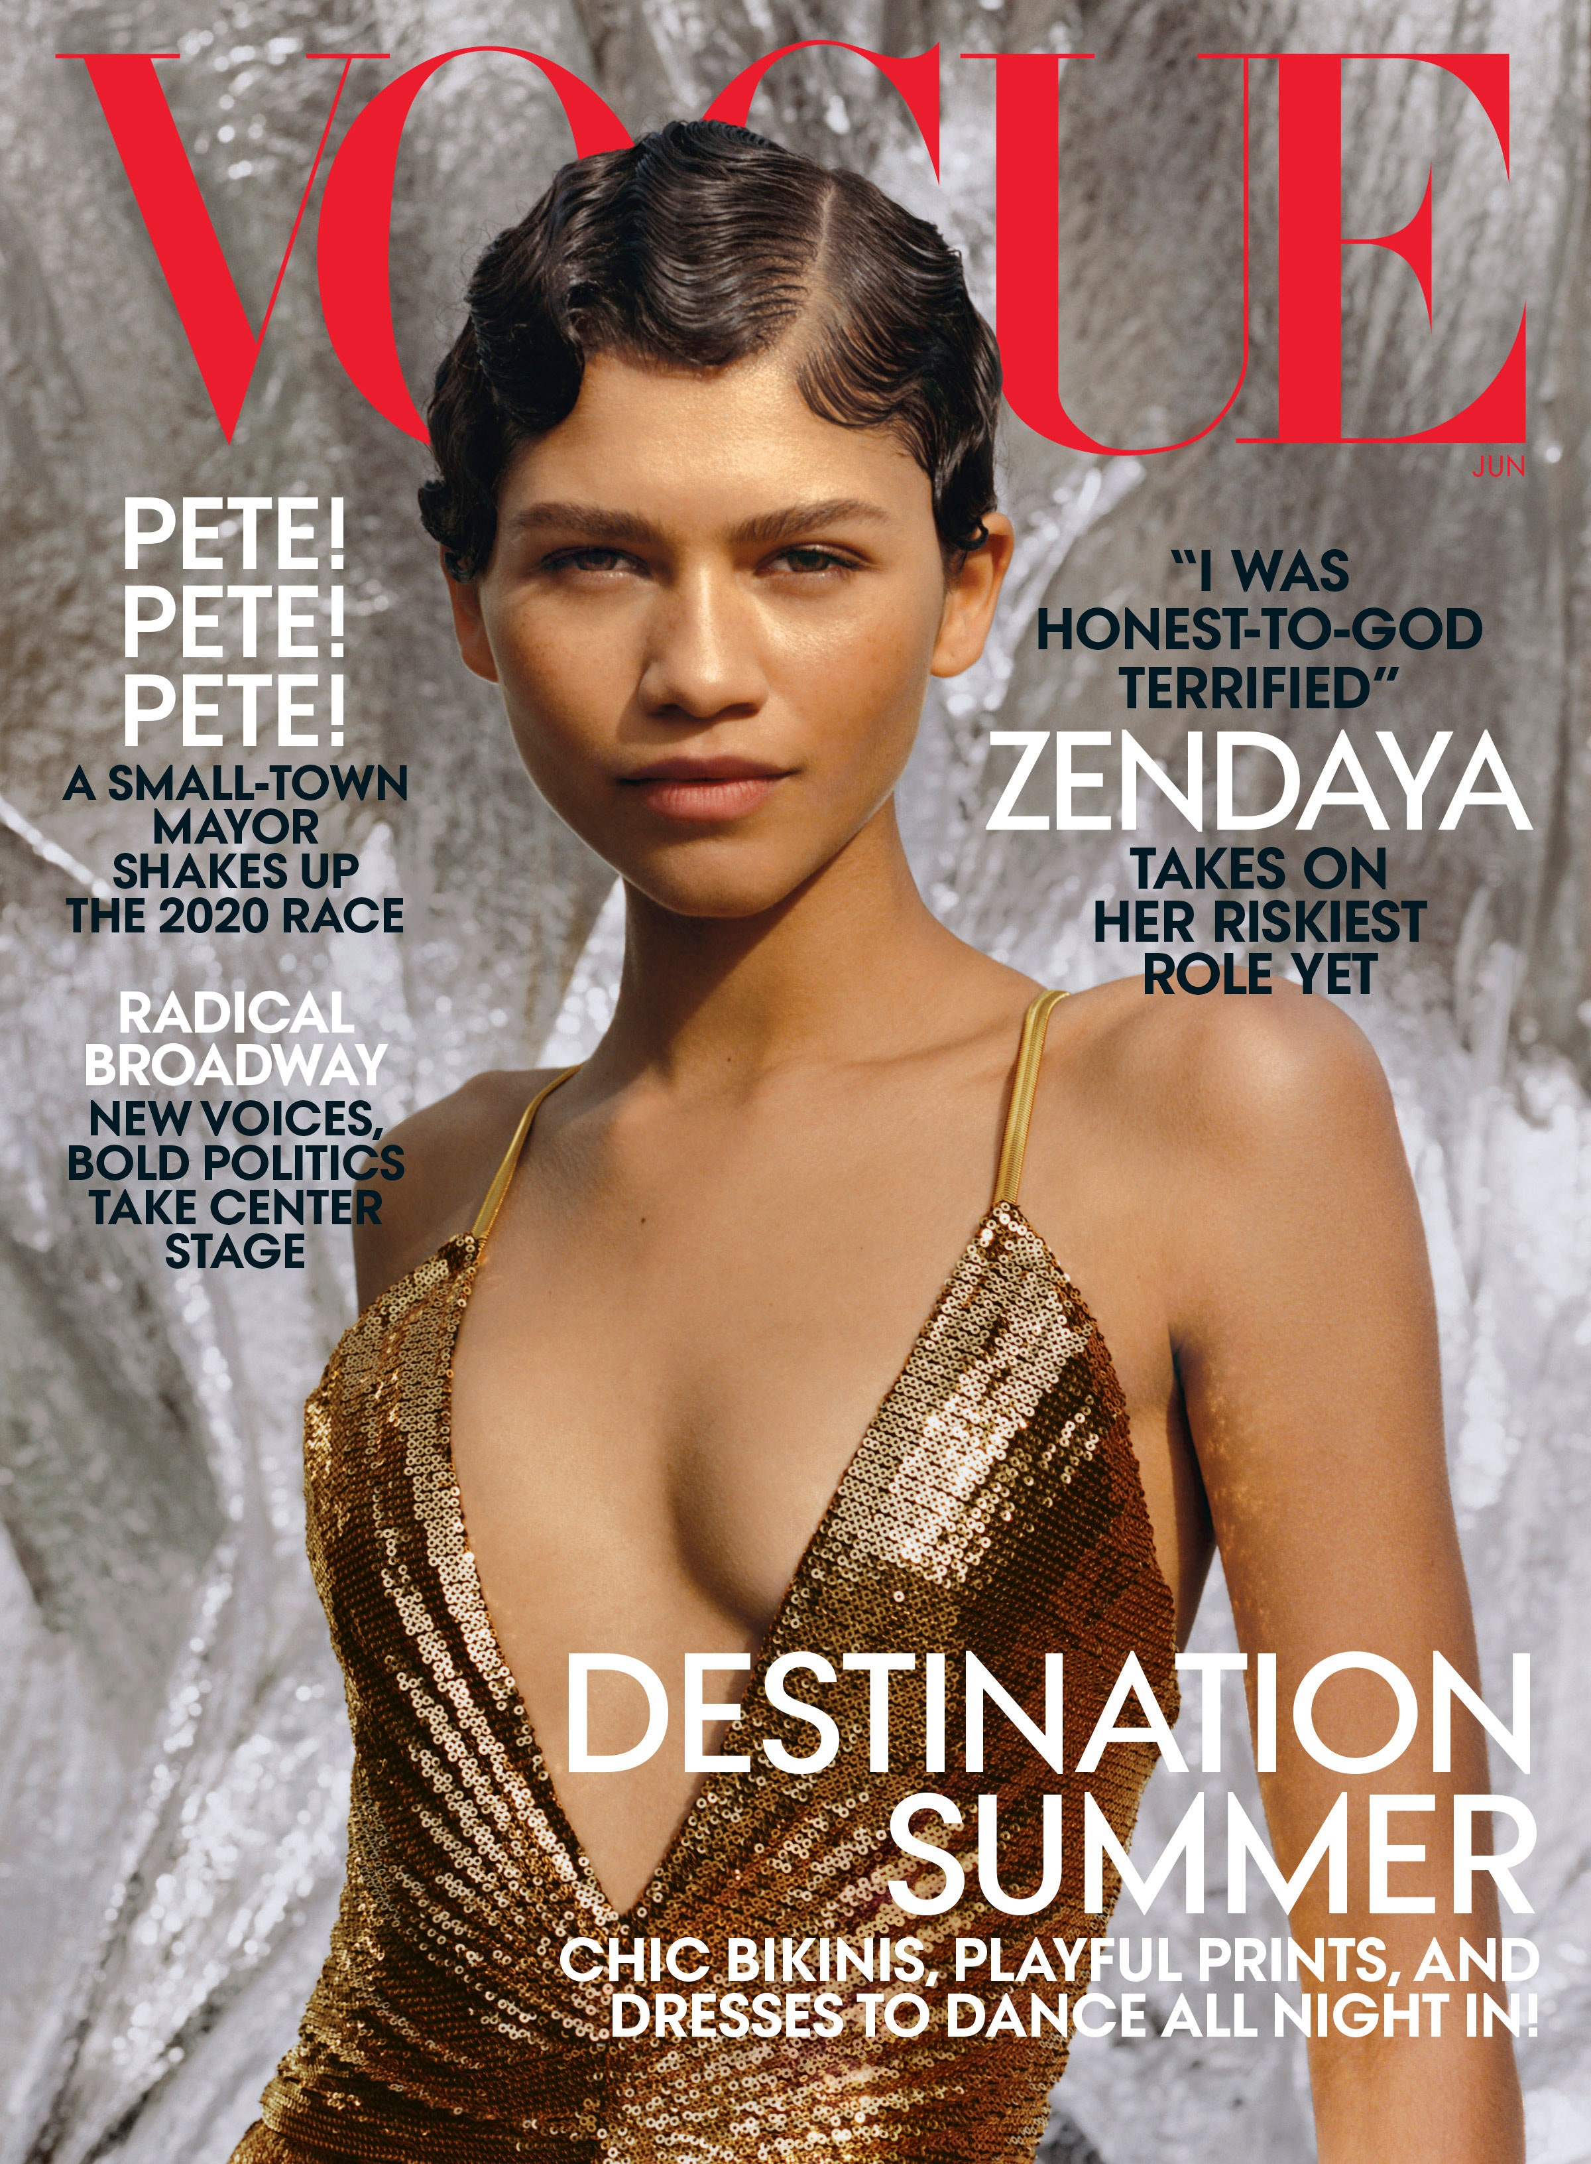
Composition and hierarchy aren't restricted to film posters- they are used in everything- for example, magazine covers. In this particular one the model is placed in front of the title, which may seem strange at first however, Vouge is one of the most famous fasion magazines, practically everybody will recognize the font and instantly associate it, it does not need to be the biggest, most important element on the page, as long as they have their famous font and a stand out colour, in this case red, it becomes further down in the hierarchy. Instead, it’s the models that draw the attention and make you want to pick it up and continue reading, they need to be bold and stand out on the page. In this example they have even put the models name in one of the biggest fonts just to add more drama so readers will recognize the name and be enticed, further adding to the successful use of composition in this image.

